AIM: Installation of Java on Unix/Linux Machine (Without Virtual Box)

Step 1:

Enable WSL (Windows Sub System for Linux) from Control Pannel

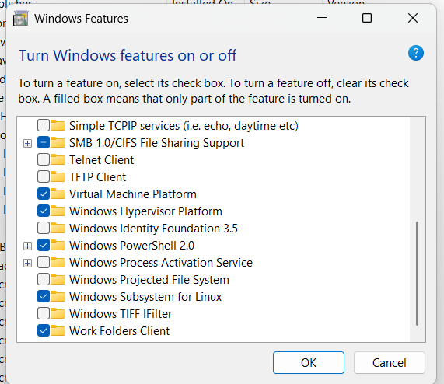

Step 2: Power Shell (Run As Administrator)

Command: wsl –-install

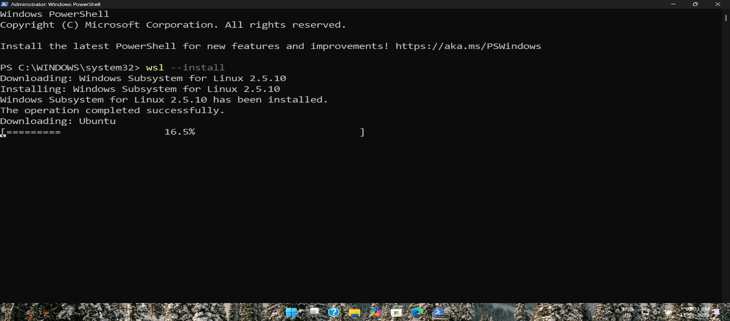

Step 3: Package Update

Command: sudo apt update

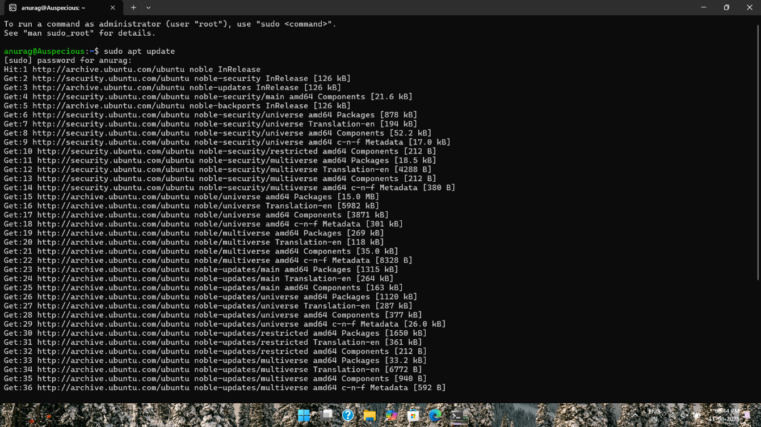

Step 4: Java Installation

Command: sudo apt install openjdk-11-jdk -y

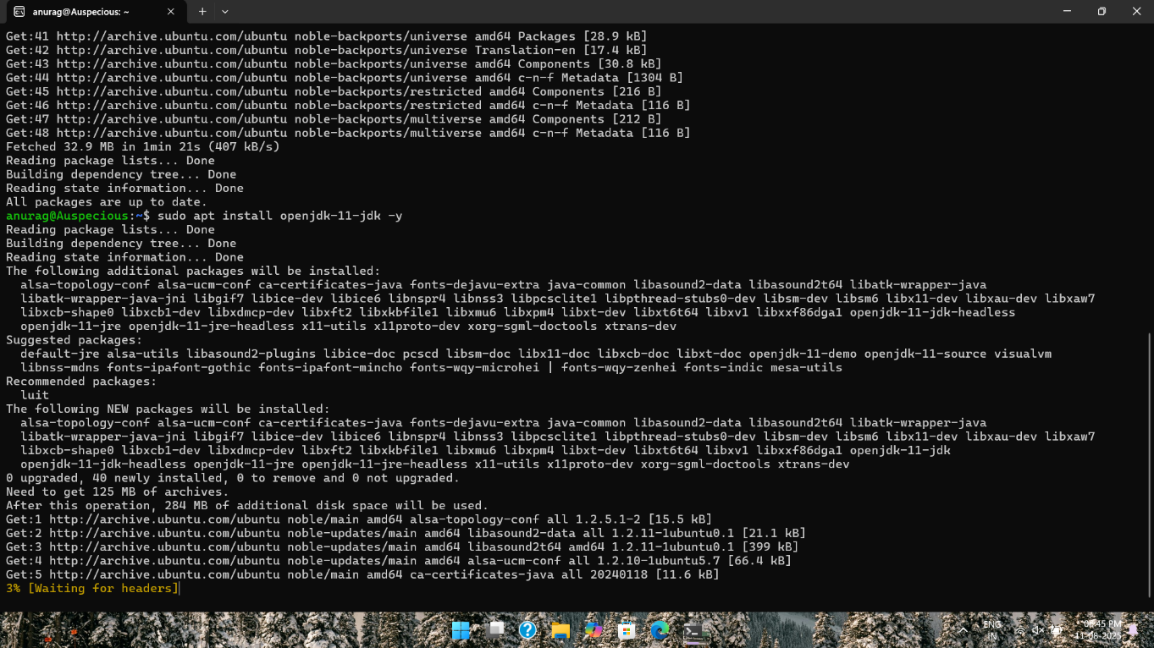

Step 5: Verify Java Installation

Command: java -version

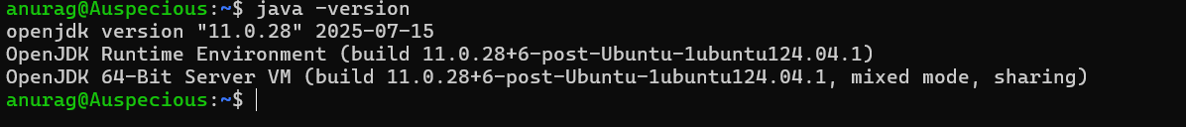

Step 6: Set JAVA_HOME Environment Variable

